assignment 10

# question 1

The Incrementable interface is used by classes which have a counter that can be incremented once, or multiple times, and reset.

Write the class IncChar which implements the Incrementable interface. IncChar has a single counter instance variable of type char. Incrementing the counter involves assigning the next Unicode char to it. The reset method assigns ‘a’ to the counter. Also include a constructor and toString method which returns the contents of the counter.

Also write the IncInt class which implements Incrementable. This time the counter is of type int and an increment involves adding 1 to it. The reset method assigns 0 to the counter. Include a constructor, toString, and method odd which returns true if the counter is currently odd.

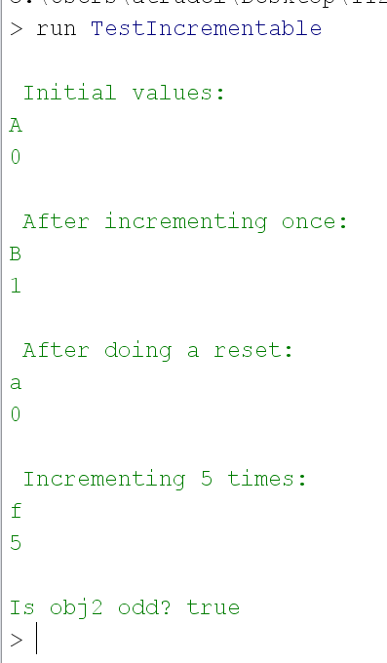

# question 2

Modify the bank account example from Chapter 4. The current code creates multiple bank accounts. But, it does not keep track of how much money in total is in the bank. Modify the Account class so that it works properly with the modified Transactions class. Do not change the toString method (tabs are not working properly on my laptop).

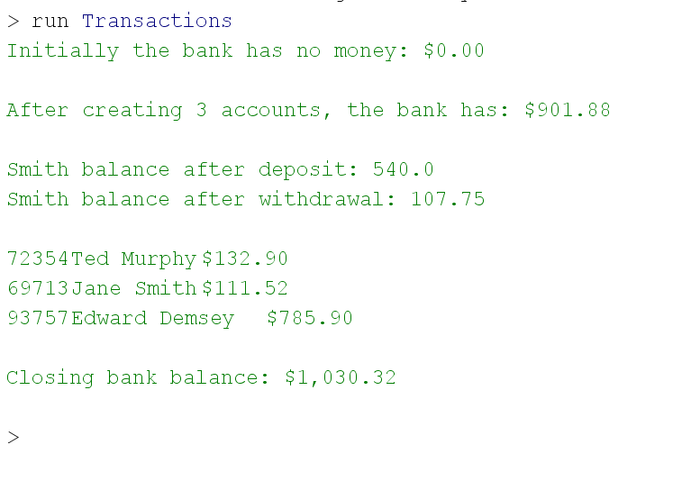

# question 3

Modify QuoteOptions and QuoteOptionsPanel from chapter 5 so that the radio buttons appear in a column to the left of the quote. Use a horizontal Box layout for the buttons and quote. The radio buttons have their own vertical Box layout. Place a blue line border around the buttons.

Initially:

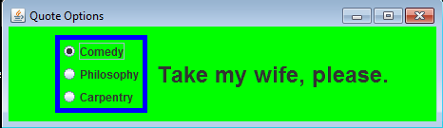

If the window is re-sized, the information stays in the center:

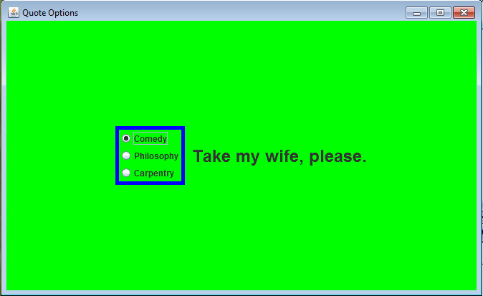

# what to submit

Submit Assignment10.zip which contains ONLY the following:

